# LAB # 5

**Objective: To verify the laws of parallel combinations of resistances using:**

1. **Ohmmeter method.**
2. **Voltmeter-Ammeter method.**

**Equipment:**

* Resistors (R1, R2, R3)
* Digital Multimeter (DMM)
* Ohmmeter
* Voltmeter
* Ammeter
* DC Power Supply
* Connecting wires
* Breadboard

**Theory**

When resistors are connected in parallel, the total (equivalent) resistance (Rt) is given by:

1/Rt =1/R1+1/R2+1/R3+......+1/Rn

**Ohmmeter Method**

An ohmmeter directly measures the resistance of a resistor or a combination of resistors. For parallel resistors, the ohmmeter measures the equivalent resistance.

**Voltmeter-Ammeter Method**

Using Ohm's Law (V=IR), we can determine the equivalent resistance of a parallel circuit by measuring the total voltage across the parallel combination and the total current through it.

Rt=Vt/It

**Procedure**

**Part I: Ohmmeter Method**

1. **Set Up the Circuit:**
   * Select three resistors with known resistance values (R1, R2, R3)
   * Connect the resistors in parallel on a breadboard.
2. **Measure Equivalent Resistance:**
   * Set the DMM to the resistance (ohmmeter) mode.
   * Connect the DMM probes across the parallel combination of resistors.
3. **Record the measured equivalent resistance (Rt)**
   * Note down the measured equivalent resistance in the observation table.
   1. C**alculate Theoretical Equivalent Resistance:**
      * Calculate the theoretical equivalent resistance using the formula:

1/Rt =1/R1+1/R2+1/R3+......+1/Rn

* + - Compare the measured resistance with the theoretical value.

1. **Voltmeter-Ammeter Method**
   1. **Set Up the Circuit:**
      * Connect the same resistors in parallel on the breadboard or resistor holder.
      * Connect the parallel resistor combination to a DC power supply.
      * Connect a voltmeter across the parallel combination to measure the voltage (Vt).
      * Connect an ammeter in series with the parallel combination to measure the current (It).
   2. **Measure Voltage and Current:**
      * Turn on the DC power supply and set it to a suitable voltage.
      * Measure and record the voltage across the parallel combination Vt.
      * Measure and record the total current flowing through the parallel combination (It).
   3. **Calculate Equivalent Resistance:**
      * Calculate the equivalent resistance using Ohm's Law:

Rt=Vt/It

* + - Compare the calculated resistance with the theoretical value and the value measured by the ohmmeter.

**Observation**

**i) Ohmmeter Method**

|  |  |
| --- | --- |
| **Resistor** | **Measured Resistance** |
| R1 |  |
| R2 |  |
| R3 |  |
| Rt (measured) |  |
| Rt (calculated) |  |

**b) Voltmeter-Ammeter Method:**

|  |  |
| --- | --- |
| Voltage (Vt) |  |
| Current (It) |  |
| Total resistance (calculated) |  |

**Results**

* + - Compare the measured total resistance from the ohmmeter method with the sum of the individual resistances.
    - Compare the calculated total resistance from the voltmeter-ammeter method with the sum of the individual resistances.

**Conclusion**

The experiment should confirm that the total resistance of resistors connected in series is equal to the sum of their individual resistances. Both the ohmmeter method and the voltmeter-ammeter method should provide consistent results, verifying the law of series combinations of resistances.

**Safety Precautions**

* + - Ensure all connections are secure and there are no loose wires.
    - Handle the power supply with care to avoid short circuits or electrical shocks.
    - Turn off the power supply when making or breaking connections in the circuit.

**Circuit Diagram:**

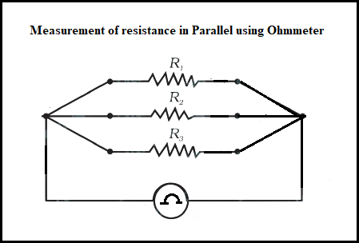

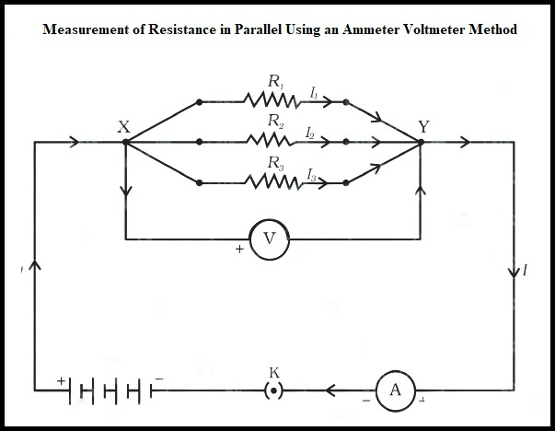

**POST LAB:**

1. What formula is used to calculate the theoretical equivalent resistance of resistors in parallel?
2. Which instrument is used to measure resistance directly in the Ohmmeter method?
3. In the Voltmeter-Ammeter method, which two quantities are measured to calculate the equivalent resistance?
4. What law is used to calculate the equivalent resistance in the Voltmeter-Ammeter method?